Our class practiced creating summaries by reading an article about pumpkins at the zoo and summarizing the article. We created pumpkins out of magazine cutouts to show our creative side and to decorate the classroom!  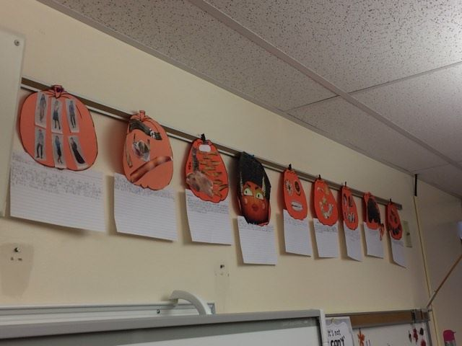  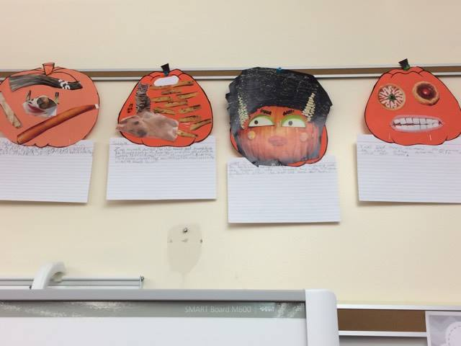 |  |  | A Message From Miss Sprecher:  We have learned so many things already in 6th grade! It is unbelievable how fast time is going. We’re already half way through! The students have put in great effort and are a fun bunch to have in class. I am looking forward to the rest of 6th grade!  Enjoy the holidays! I hope it is a time well spent with family and friends filled with lots of laughter, joy, cherished memories, and some relaxation! See everyone in 2017!  Of course, if you have any questions, concerns, or comments, please feel free to e-mail me at jsprecher@bigspring.k12.pa.us or call at (717) ex. 8125  Sincerely,  Miss Sprecher  Sincerely,  Miss Sprecher |  |  | Big Spring Middle School  6th Grade English Class  - 2016-2017

We’ve been busy learning in English class:  Some of the main topics we covered so far in 6th grade are as follows:  - MLA Heading  - Annotating text  - Central Idea and Supporting Details  - Summarizing  - Writing Informational Text (ask who they wrote about!)  - Inferencing, analyzing, generalizations  - Citing evidence  - Anecdotes  - Vocabulary  - Sequence of Steps  - Subject/Verb Agreement |  |  | 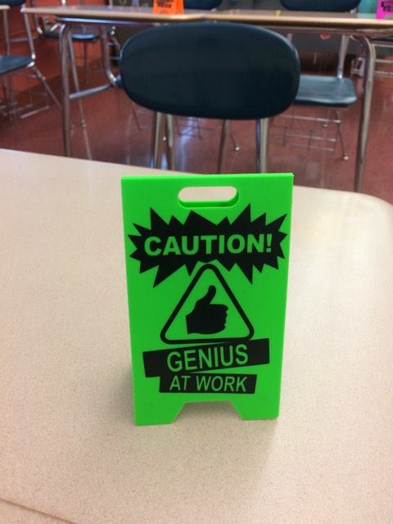  Signs like this one here are placed at the students’ desks during all quizzes to encourage students to keep working hard and do their best.  “Learning is a treasure that will follow its owner everywhere.”  - Chinese Proverb |  |  | 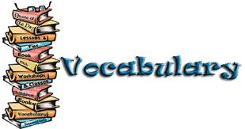  We also have been working hard at expanding our vocabulary. The students are assigned different word parts (prefixes or suffixes) in order to choose their vocabulary words. They have to research what their word part means, choose two example words with that word part, create a word list, flash cards, and then a project using their vocabulary words.  It’s also a collaborative project because the students share their research with each other, teaching their peers the new words. The students are then quizzed on all of the words.  These are the word parts we have learned so far:  - tele  - chron  - fix  - mono  - fy/ify  - pro  - Auto  - Able/ible  - be  - ist  - mis  - claim/clam

